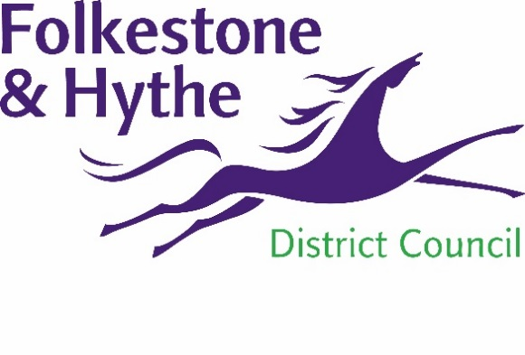
NEWS RELEASE

28 January 2020

FIRM APPOINTED TO DELIVER FOLKESTONE TOWN CENTRE PLACE PLAN

Folkestone & Hythe District Council has appointed architecture and urbanism experts We Made That to deliver a Place Plan for Folkestone Town Centre.
We Made That is an experienced practice with a strong track record of working successfully with the public sector and communities to promote positive change in town centres. They have developed innovative methods for engaging wide ranging groups of stakeholders and this is an essential part of the commission to develop a plan to ensure a vibrant future for Folkestone.
We Made That will lead the design team for the project and has brought together a diverse team of different specialists to ensure the success of the project. Fletcher Priest will contribute their expertise to the architecture of specific opportunity sites, with transport and infrastructure consultants Steer looking into access, and socio-economic analysts PRD advising on economy and town centre business opportunities and the Night Times Industry Association providing support to review the existing licensing policy. .
Working with the council, We Made That and partners will be engaging with stakeholders, businesses and residents to identify opportunities to build on the inherent strengths of the town centre and the positive investments made by the public and private sectors to date.
Cllr David Wimble, F&HDC Cabinet Member for the District Economy, said: “We Made That impressed the panel with their proposed approach, the quality of the team and enthusiasm for the project to. They also have a very strong track record of community engagement which is of vital importance in developing a future ambition for Folkestone town centre.
“This Place Plan will harness the immense potential of Folkestone Town Centre and set out a vision and actions we can all get behind to create a town fit for our extraordinary community.”
Cllr Danny Brook, Chair of Folkestone Town Centre Working Group, said: “Folkestone is such a special place and I’m delighted that we now have experts in place to help us capitalise on the opportunities in Folkestone Town Centre that will benefit businesses and residents alike.”
Holly Lewis, Co-founding partner of We Made That, said: “Our team is excited to build on the enthusiasm of the people of Folkestone for their Town Centre and work together with them to produce a clear plan for its future that encompasses public spaces, roads, development and new activities.’
We Made That will start engaging with the local community later this year.

More information about the project can be found at folkestone-hythe.gov.uk/placeplan

ENDS

Notes to Editors:
For more information, please email communications@folkestone-hythe.gov.uk

Follow us on Facebook: @FolkestoneandHytheDC
Follow us on Twitter: @fstonehythedc
Follow us on Instagram: @folkestonehythedc
Follow us on LinkedIn: Folkestone & Hythe District Council

We Made That

We Made That is an energetic architecture and urbanism practice with a strong public conscience. They work with their clients to prepare incisive urban research, to develop responsive area strategies and masterplans and to deliver distinctive architecture and public realm projects through socially-engaged design processes

www.wemadethat.co.uk

